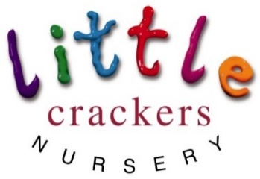 **Weekly News**

**24th May 2019**      2!!!

|  |  |  |
| --- | --- | --- |
| Nursery notices:  **Pre-school parents – please take note of the Graduation and Sports Day dates.**  **Unfortunately only 2 adults per child can come to Graduation because of space, but everyone is welcome to the Sports Day.**  Image result for happy bank holiday weekend | | Dates to remember:  Half term (term time children)  Mon 27th May-Mon 3rd June  Image result for sports dayImage result for sports dayImage result for sports day  **SPORTS DAY!!!**  Thursday 13th June 9.30am  Image result for graduationImage result for graduationImage result for graduation  **PRE-SCHOOL GRADUATION!!!**  Tuesday 25th June (afternoon)  Image result for sunImage result for sunImage result for sunImage result for sunImage result for sun  School closes for the Summer  (term time children)  Wednesday 3rd July |
| Image result for butterflyImage result for butterflyImage result for butterflyImage result for butterflyImage result for butterflyImage result for butterflyImage result for butterflyImage result for butterflyImage result for butterflyImage result for butterflyImage result for butterflyImage result for butterfly | | |
| **Joke of the week…**  [Image result for laughing faceImage result for laughing faceImage result for laughing faceImage result for laughing face](https://www.google.co.uk/url?sa=i&source=images&cd=&cad=rja&uact=8&ved=2ahUKEwjCuOHo0vjaAhUCwxQKHSwQC4MQjRx6BAgBEAU&url=https://www.pinterest.com/pin/127086020713247253/&psig=AOvVaw1FHD7HrA2htc7A-7VxJXpP&ust=1525955880069044)  **What is the difference between knowledge and wisom…**  **Knowledge is knowing a tomato is a fruit**  **Wisdom is knowing NOT to put it in a fruit salad!!!!!** | Caterpillar Watch…  Image result for insect lore caterpillarsImage result for arrow  We **still** have 5 cosy cocoons in the net!!  (Looks like the all year round children are in for a treat!!!) | |

Little Crackers Nursery · Crackley Hall · St Joseph’s Park · Kenilworth · CV8 2FT

Telephone: 01926 514444 · Fax: 01926 514455 · e-mail: littlecrackers@crackleyhall.co.uk

[www.crackleyhall.co.uk](http://www.crackleyhall.co.uk)

Registered Charity Number 1087124 Company limited by guarantee Number 4177718

 

You can email Mrs Bird [clarebird@crackleyhall.co.uk](mailto:clarebird@crackleyhall.co.uk)

or ring the nursery direct **01926 514456**